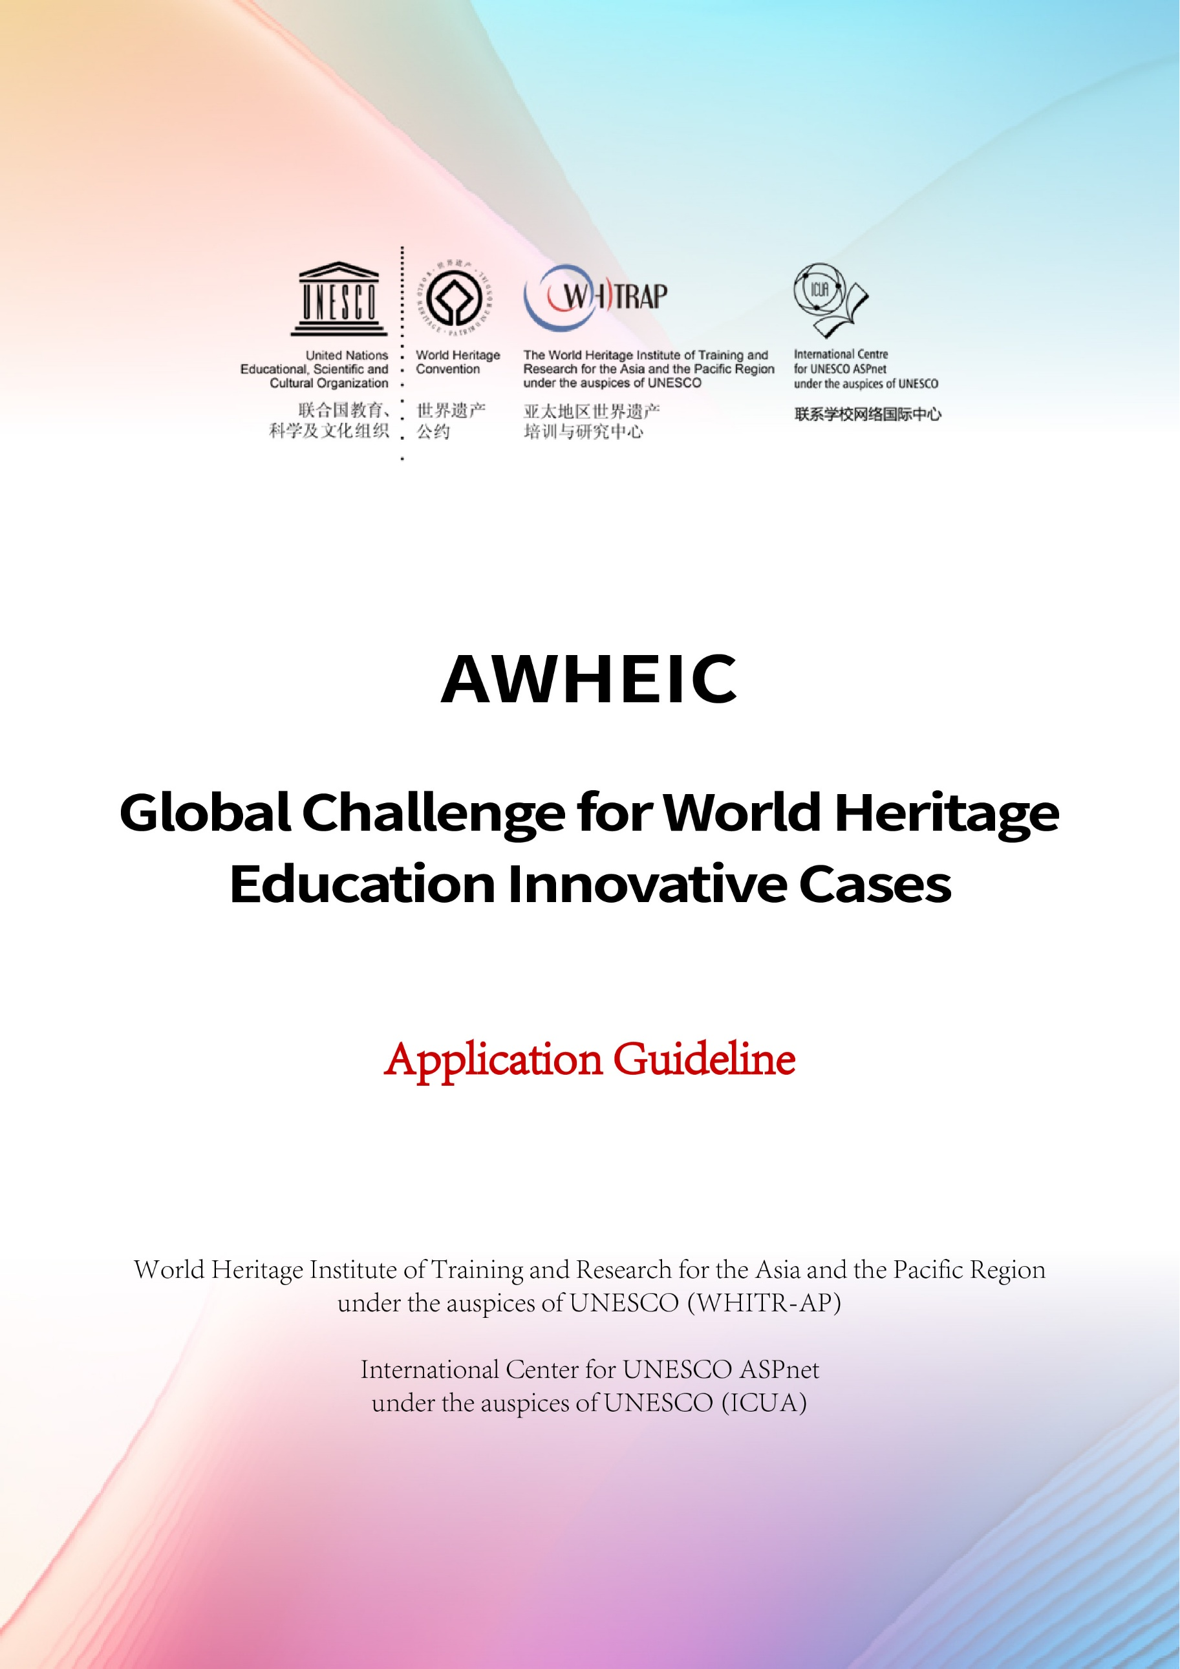
1. List of application materials and format requirements

List of application materials and format requirements
List of application materials | Significant level |  | Format requirements
A (Application Form) | Core mandatory document |  | - PDF and editable WORD formats.  - In English.  - Folder prefix naming rules: A;
D (Declaration Form) | Mandatory |  | - In English, after filling out, please print and sign it, stamp it/affix a seal, and scan it into a separate document (or take a high-resolution photo);  - Folder prefix naming rules :D;
P (Photo) | Mandatory |  | - It is recommended to divide your documents into two groups: selected photos, not more than 10 (P1), and general photos (P2). It is recommended to send in the form of compressed packages.  - Folder prefix naming rules: P, such as P1, P2 ......
V (Video Files) | Recommended |  | - Please send with email attachment, 3-15 minutes max, labelled video name, AVI format, English or with English subtitles. Provide a short paragraph to explain what the focus of the video is to help the jury understand. Provide author and copyright information (mandatory). Provide if possible high-precision video for later promotion.  - Folder prefix naming rules: V, such as V1, V2 ......
O (Others) | Optional |  | - Project introduction PowerPoint, relevant media coverage materials and other supplementary materials.  - Other relevant materials can be provided within reasonable limits.  - Folder prefix naming rules: O, such as O1, O2 ......
Email format requirements
- Email Subject title format: region or country + city + case keywords.
- List all the names of the submitted document in the email. All materials are sent as email attachments or via a link (i.e. several folders containing A, D, P1, P2, V, etc.). If they are sent by WeTransfer or a similar tool, please provide a valid link in the transmission email.
- The WHITR-AP team will acknowledge receipt within 2 working days.
Designated email address |  | 44whc@whitrap.com
Backup email address |  | creativeheritage@163.com

- Frequently Asked Questions
Q: Are sites not on the UNESCO World Heritage List eligible for application?
A: Yes.
AWHEIC focuses on the promotion of heritage values in a broad sense and their dissemination. The World Heritage Convention focuses on the identification of heritage, therefore AWHEIC is not limited to the UNESCO World Heritage List. All types, categories of heritage sites, natural, cultural, mixed, cultural landscapes, historical villages, monuments, and intangible cultural heritage can apply. However, movable objects are not considered, unless they contribute to the definition of tangible attributes or intangible features.

Q: How to better highlight the characteristics of the case in the preparation of the application file?
A: The focus of AWHEIC is to discover, encourage and promote model innovation in the field of heritage.
This model of innovation can be reflected in several aspects, including one or more aspects of the concept, technology, diversity or organizers and beneficiaries, cooperation, and communication, usually with the help of creative or technological (not necessarily high-tech).

Q: Are the beneficiaries necessarily young people?
A: Not necessarily.
We believe that heritage education is a broad concept related to all people, including all kinds of formal or informal groups, and the participants and beneficiaries include all sorts of people, including young people.

Q: How to reflect the exemplary nature of the case?
A: As much as possible, the case should be enhanced from a professional and theoretical level, thus contributing to spreading and promotion role models.
Please analyze and present the characteristics and significance of the case in terms of model development so that more people can be inspired by them.
Such exemplary includes both direct and potential or cutting-edge exploration, such as immature but to a certain extent represents the new direction of the future.

Q: We are from a less developed region. Will some support and assistance during the application process be provided?
A: Achieving regional balance and providing support for less developed regions are one of the principles of AWHEIC, which is mainly reflected in the following aspects:
We will give more consideration to social and economic sustainability and the adaptability of technology to the local environment. For example, in less developed regions, appropriate common technology is more effective than high technology.
We will consider a certain degree of balance, with a certain preference towards less developed regions such as rural areas, Africa, and the Pacific Islands (e.g. the 2021 project from Africa, etc.).
We may carry out certain technical and professional support pro bono (including but not limited to funding, technological assistance, personnel, etc.).

Q: Can a purely online educational case be accepted?
A: Yes.
Considering the irreproducibility of heritage value in nature, AWHEIC presents a higher threshold for purely online cases.

Q: Is there a limit to the number of applications from one institution (individual)?
A: There is no limit.
Considering a large number of accepted cases, it is recommended to choose 1-2 projects for application.
Because it involves the recognition of winners and related global promotion, in principle, there can only be one main application organization for one project.

Q: Will recommendations from experts be accepted?
A: Yes
For the better identification of good cases, we accept third-party recommendations.

Q: Will bonuses be offered for winning cases?
A: As an innovation, AWHEIC offers something more valuable than bonuses.
AWHEIC is positioned as an incubator for the future era, which emphasizes the in-depth interaction between the organizer, partners and the outstanding cases. It is more like a membership club that brings together all kinds of international high-end resources to provide comprehensive support for the winning cases, including international cooperation, professional exchange, promotion, opportunity matching, technical support, financial support and services.
AWHEIC has built a strong international cooperation network, including but not limited to UNESCO system, UNOSSC, heritage sites, universities, various foundations, new media, incubators, etc. The winners can connect with them and benefit from the cooperation network value far beyond money.
The winners will have the opportunity to be invited to the activities organized by the organizers and parters of AWHEIC and to present the cases. The organizers will support all or part of the travel costs of representatives from selected regions.

Q: How can I get involved in AWHEIC’s collaborative network and incubation project program?
A: You can apply to join an existing scheme or make an application to the organizer for a cooperative scheme.
With the continuous strengthening of AWHEIC's cooperation network, and based on the demand for cross-border cooperation from many applicants, AWHEIC launches the Cooperation Project Incubation Program in 2023, with the first phase of projects including the Sino-Mexican Heritage Cities Cooperation Project etc. Based on the concept of building and sharing, many of these projects are formed through interactive discussions between the organizers and the case applicants, and the related mechanisms are continuously improved.
All parties are welcome to participate in various forms, and all winners enjoy priority in the activities.

