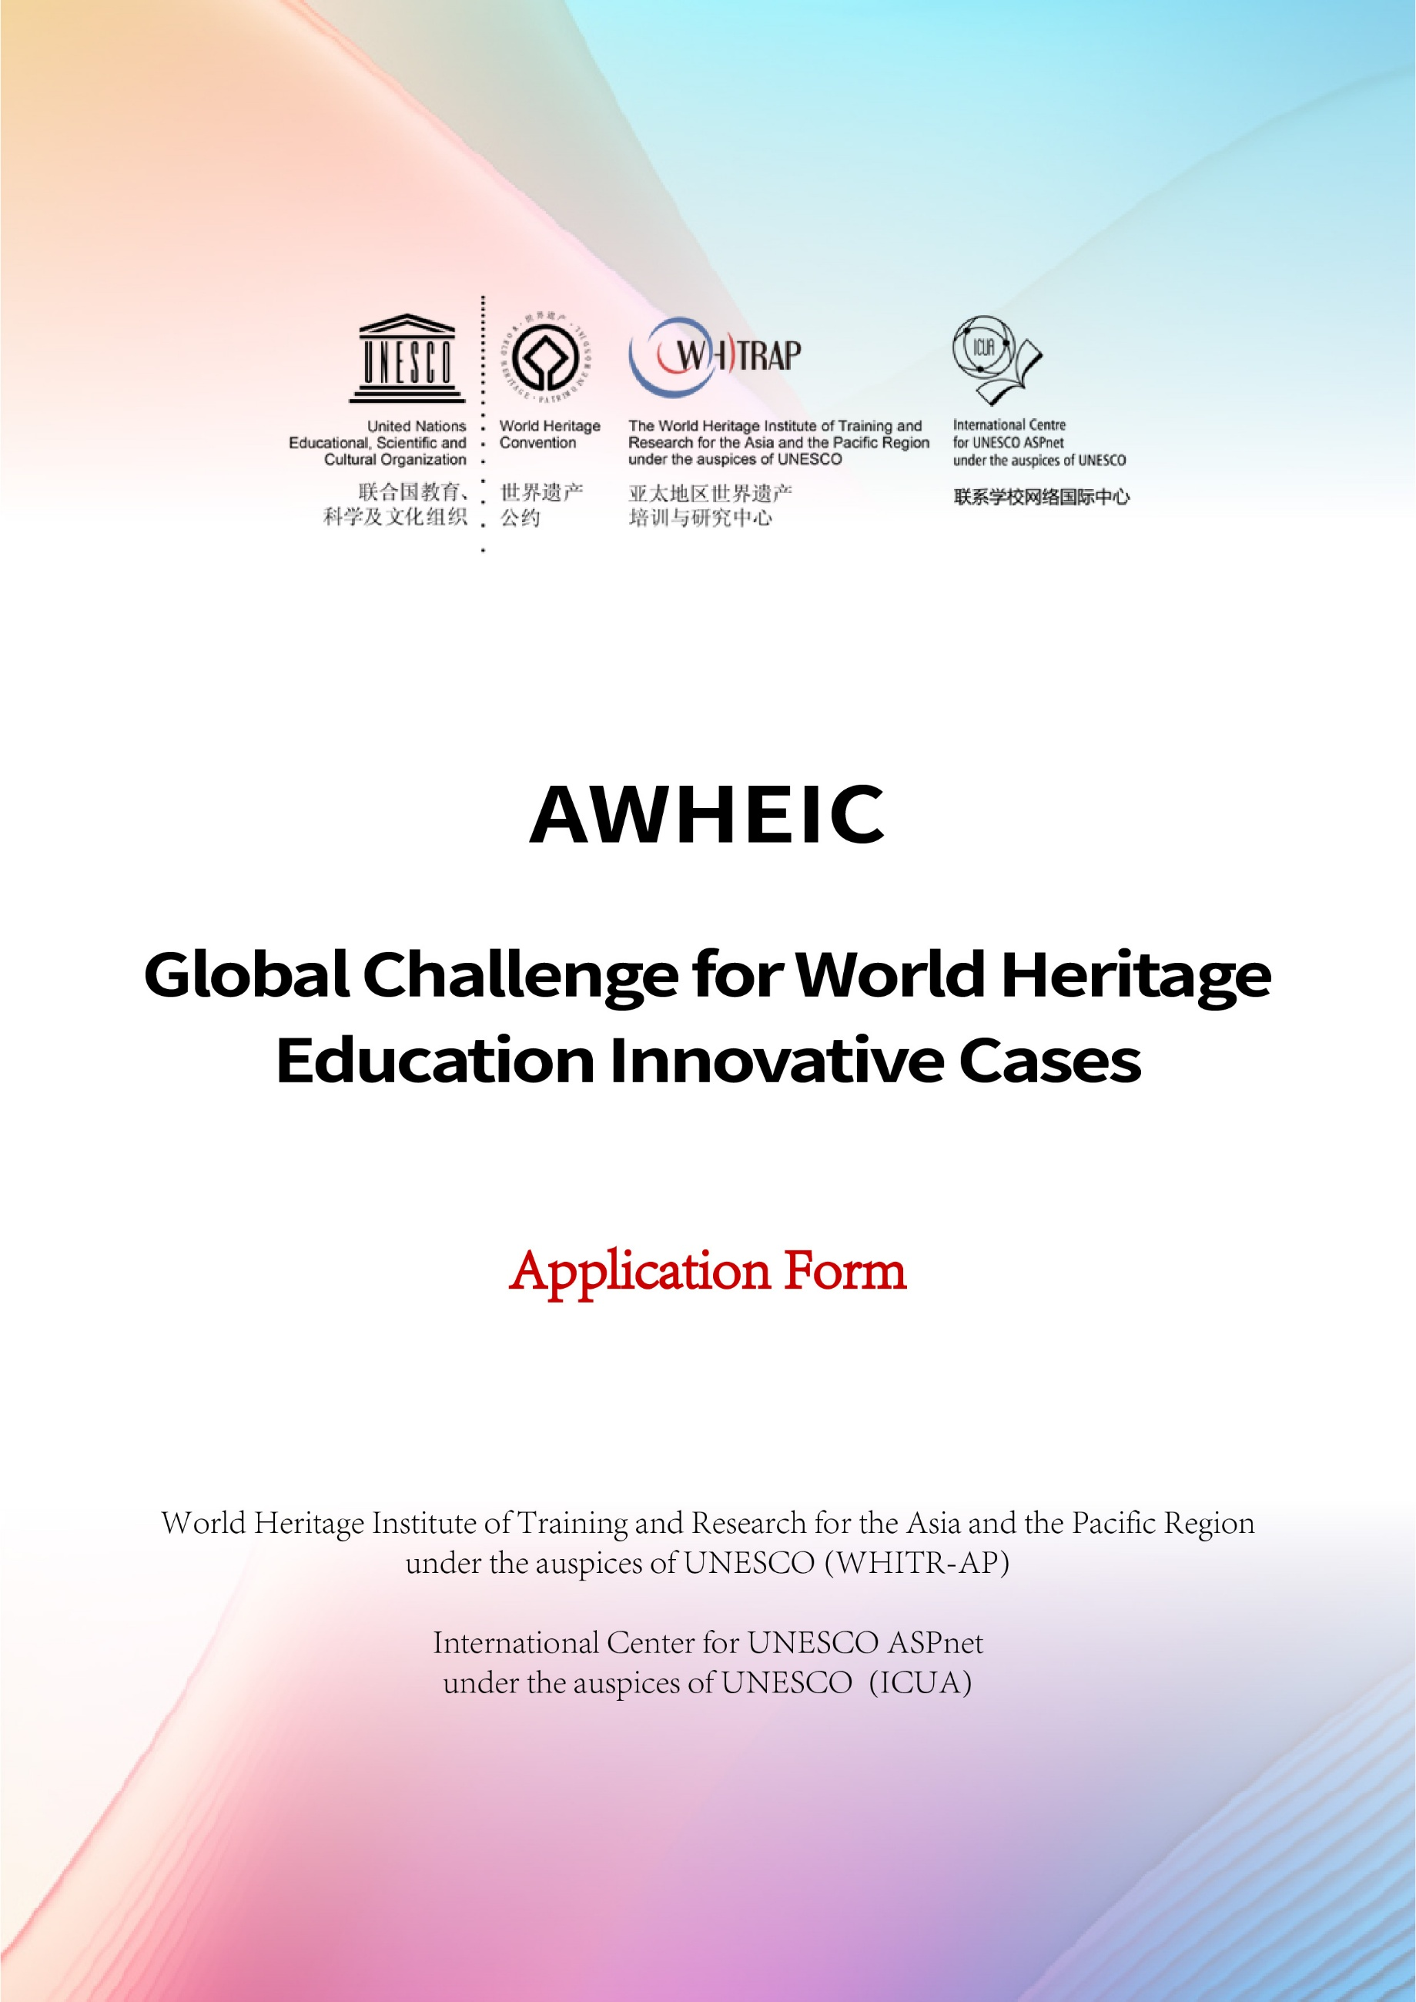

Please make sure you read the following instructions
carefully before filling in and sending the form.
- The standard application form is prepared by the organizer of AWHEIC and shall not be altered in any way.
- The evaluation criteria of AWHEIC focus on innovations of models of heritage education cases, in particular the innovation of content, approach and model by means of creativity, science, technology and cross-border cooperation. The content of the entries should be general in nature and relevant to the requirements of the columns, avoiding the accumulation or repetition of information. All fields must be filled in. If there is no corresponding content available, please fill in "NONE".
- The official working language of AWHEIC is English, and the Application Form should be completed in English. Considering the efficiency of the evaluation, we will provide the Application Form in French, Spanish and Chinese at the same time, and the working group will accept the separate Application Form in English, French or Spanish, and the cases from China must provide the Application Form both in English and Chinese at the same time.
- 4. Please note that some sections have strict word limits. Once the word limit is reached, no further text can be added, and the "word count" auxiliary function can be used to ensure that the word limit is not exceeded.
Application Form
Title of Case
Applicant (Institution/Individual)
Stakeholder/entity leading the case
（the person in charge will attend the side event and present the case if the case is selected.）
Name |  |  |  | Email
Tel. No. |  |  |  | Email
Position and Title
Contact Address
Communication Contact
（The communication contact will be responsible for supporting the communication efforts during application process. Leave this section blank if the contact are the same as the stakeholder）
Name |  |  |  | Email
Tel. No. |  |  |  | Email
Position and Title
Contact Address
- Background and brief introduction of the case
The summary should cover the basic info of the case, e.g. description, major participants and partners and targeted groups etc. (Max.750 words)
2、Overall description of the Innovation of the model of heritage education of the case
1. Basic challenges faced, main idea and methods during the problem-solving process; 2. The main concepts, contents, methods, and other characteristics of the model innovation of the case, especially the innovative or new increment in contrast to existing cases; 3. The replicability and global demonstration significance of the case. (Max. 750 words)
3、How the case meet the 5 Criteria: SCEIT Model of heritage education model innovation
Detailed description of how the case meet the 5 Criteria, in another world 5 aspects of the case model innovation based on SCEIT Model. Fill in at least 2 of 5 Criteria, please indicate "none" if there are no related contents (Max.500 words for each criteria)
- Embracing Science
Exploring new methods or models, by innovatively utilizing modern or traditional science and technology, which lead to better exploration, interpretation and dissemination of heritage values.
- Creativity Inspiring
Exploring new heritage education ideas or approaches considering local context by creativity, which expand or strengthen innovative interactions between people and heritage.
- Empowering Sustainability
Tap the potential of heritage from different perspectives by innovation, empowering the comprehensively sustainable development of heritage sites.
- Social Inclusion
Innovatively promoting the communication and integration of different social groups, which leads to the inclusive development of local community.
- Transboundary Cooperation
Exploring innovative mechanism and models of transboundary cooperation at local, regional or international level, enhancing the synergy of different parties related to heritage.
4、Others
This part is open and up to you to provide any contents which is helpful to further understand of the innovation of the case. And also your important suggestions to AWHEIC, e.g. your expectation, need，initiation of AWHEIC incubator projects, and so on etc. (Max. 500 words)

